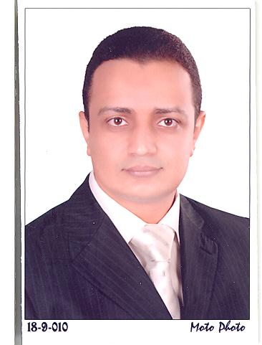

Curriculum Vitae

PERSONAL INFORMATION:

- Name: Mohamed Aly Hassan Abdelhafez
- Sex: Male.
- Date of birth: 22/8/1980.
- Place of birth: Egypt.
- Nationality: Egyptian.
- Marital state: Married.

For Correspondence:
- Address: in Egypt, Department of cardiology, Assiut University Teaching Hospital, Assiut, Postal Code 71526, Egypt.
- E-mail: mohamed.abdelhafez@aun.edu.eg ,mohamedali.abdelhafiz@hotmail.com
- Home: +20-88-2322167.
Mobile: +20-1065889346.
Fax: +20-88-2356753.
- Current Position:
- From 1/04/2012 till 31/03/2014: Guest Doctor in West German Heart center Essen
- Assistant Lecturer, Department of cardiology, Assiut University Hospital, Assiut, Egypt.

QUALIFICATIONS:
- M.Sc. in cardiology "v. Good", (2008)
Title of the essay is "the long term outcome of drug eluting stent",
Faculty of medicine, Assiut University.

- M.B.B.Ch. of Medicine and General Surgery " excellent with honor", (2003)
Faculty of medicine, Assiut University.

Training Posts:

- Feb. 2008 – Present: Assistant Lecturer.
- March 2005 – Feb. 2008: cardiology Resident:
In the department of cardiology , Assiut University Teaching Hospital, (The largest tertiary medical center in Upper Egypt).
Summary of duties:
- Responsible for management of patients in the Department of cardiology : attending out-pt. clinic, admission of patients, caring for pts. in CCU , doing echo-examination in the echocardiography unit , precath. preparation, assisting in different diagnostic and therapeutic cardiac interventions (diagnostic coronary angiography , precutaneous coronary intervention , precutaneous mitral balloon valvuplasty, Pulmonary valvuplasty , pacemaker implantation ).

- March 2004 – February 2005: Internship:
One year training at Assiut University Teaching Hospitals: (The tertiary hospital of the Upper Egypt, 2000 beds).
Summary of duties:
- Rotations every 2 months between different specialties: General Surgery, Internal Medicine, Gynecology & Obstetrics, Pediatrics, Accident & Emergency and Anesthesia.
- Basic training in different branches of medicine.
- By the end of the Pre Registration period, the Egyptian Medical Syndicate registered me as a Medical Practitioner on the first of March 2005.

Academic Experience:
- Regular meetings and conferences, research studies were attended and arranged during 3 years of residency.
- Helping in teaching of Medical students with regular rounds, lectures preparation and regular clinical training supervision.

CONFERENCES:
- The Delta-c project on cardiovascular disease prevention 2007.
- The annual conference of thrombosis and hemostasis 2008, 2009.
- The international day of hypertension 2007 & 2008.
- The CardioEgypt annual conference of the Egyptian society of Cardiology 2010.
- Cardiosouth 2010.
- ESC Paris 2011

FUTURE PLANS:
- M.D. degree in cardiology.
- Interested in interventional cardiology especially adjunctive devices in primary PCI intervention.

LANGUAGES AND IT EXPERIENCE:
- Arabic.
- English (with toefl iBT score= 86).
- Advanced Computer skills, Power point presentation skills.

LEISURE ACTIVITIES:
- Reading and listening to classic music.
- Playing soccer and table tennis.
- Traveling and site seeing.
- Watching movies.

REFERENCES:

Prof. Yehia Taha Kishk , M.D.
Professor of interventional cardiology .
Faculty of Medicine - Assiut University
Assiut University Building, Assiut-Egypt 71526

e-mail : ytkishk2002@yahoo.com
H (+20-88) 2317667
M (+20-12) 3971269

Prof. Salwa Roshdy Dimitry , M.D.
Professor of interventional cardiology .

Faculty of Medicine - Assiut University
12 Yousry Ragheb street, Assiut-Egypt 71526

e-mail : salwadimitry@yahoo.com
H (+20-88) 2334133
M (+20-12) 3971267
H (+20-88) 2372934

M (+20-18) 2274231

Signature:

Mohamed Aly Hassan

